Implement clustering techniques – Hierarchical and K-Means

1. **HIERARCHIAL CLUSTERING**

**CODE:**

# Load the iris dataset data(iris)

# Use only the numeric columns for clustering (exclude the Species column) iris_data <- iris[, -5]

# Standardize the data iris_scaled <- scale(iris_data) # Compute the distance matrix

distance_matrix <- dist(iris_scaled, method = "euclidean")

# Perform hierarchical clustering using the "complete" linkage method hc_complete <- hclust(distance_matrix, method = "complete")

# Plot the dendrogram

plot(hc_complete, main = "Hierarchical Clustering Dendrogram", xlab = "", sub = "", cex = 0.6) # Cut the tree to form 3 clusters

clusters <- cutree(hc_complete, k = 3) # Print the cluster memberships print(clusters)

# Add the clusters to the original dataset iris$Cluster <- as.factor(clusters)

# Display the first few rows of the updated dataset head(iris)

**OUTPUT:**

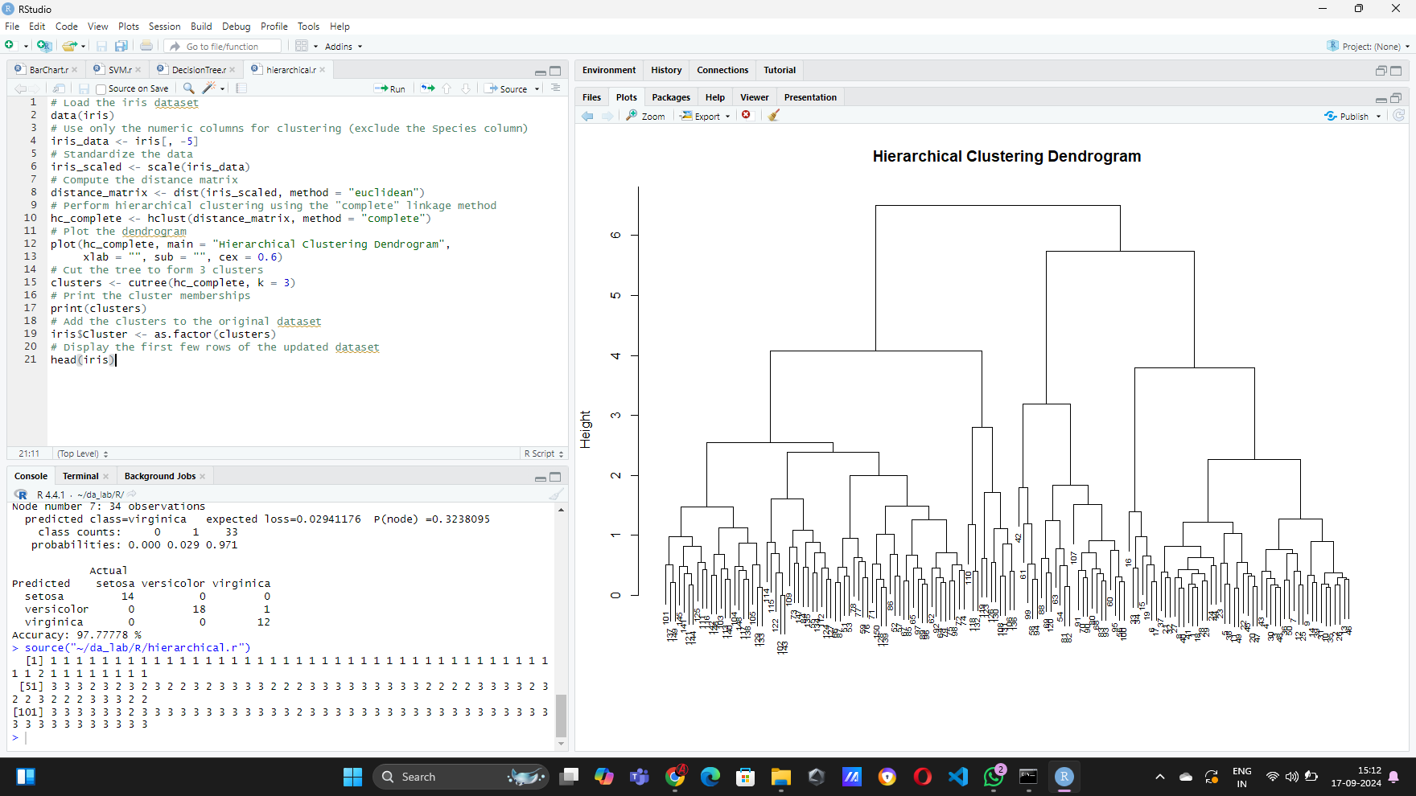

1. **K-MEANS CLUSTERING**

**CODE:**

# Load the iris dataset data(iris)

# Use only the numeric columns for clustering (exclude the Species column) iris_data <- iris[, -5]

# Standardize the data iris_scaled <- scale(iris_data) # Set the number of clusters

set.seed(123) # For reproducibility k <- 3 # Number of clusters

# Perform K-Means clustering

kmeans_result <- kmeans(iris_scaled, centers = k, nstart = 25) # Print the K-Means result

print(kmeans_result)

# Print the cluster centers print(kmeans_result$centers)

# Add the cluster assignments to the original dataset iris$Cluster <- as.factor(kmeans_result$cluster)

# Display the first few rows of the updated dataset head(iris)

# Plot the clusters library(ggplot2)

ggplot(iris, aes(x = Sepal.Length, y = Sepal.Width, color = Cluster)) + geom_point(size = 3) +

labs(title = "K-Means Clustering of Iris Dataset", x = "Sepal Length", y = "Sepal Width")

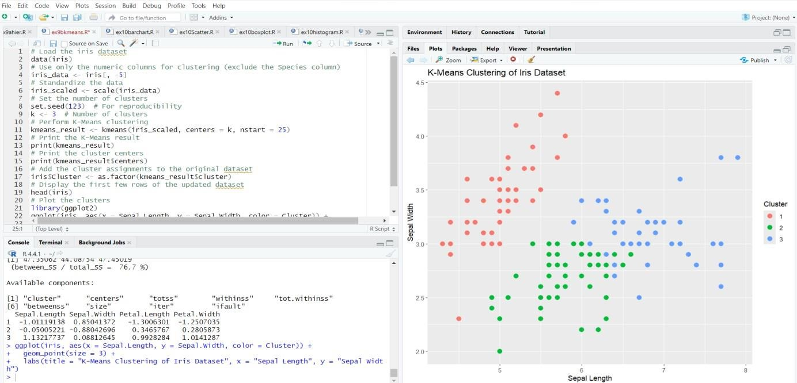

**RESULT:**

Thus clustering techniques such as Hierarchical and K-Means clustering implemented successfully.